28.40: a) 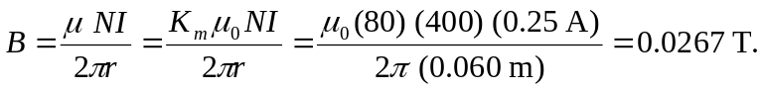
b) The fraction due to atomic currents is 